# **Lab Assignment 11 - Dashboards**

## **Problem Statement 1:-**

In teams of 2 or 3 or as an individual, create a dashboard keeping in mind the key pointers discussed in class.Take a dataset snippet from UCI repository or Kaggle for the same..

### **Algorithm/ Code :**

// Index.html

<!DOCTYPE html>

<html lang="en">

<head>

<meta charset="UTF-8">

<meta http-equiv="X-UA-Compatible" content="IE=edge">

<meta name="viewport" content="width=device-width, initial-scale=1.0">

<title>Deashbord</title>

<link rel="stylesheet" href="style.css">

<!-- Color : #f07d51, #1b1a18, #312d2a -->

</head>

<body>

<nav>

<h1 class="nav-heading">Country List</h1>

<input type="text" id="find_country">

<ul class="nav-country-list" id="countryList">

</ul>

</nav>

<main>

<section class="main_section">

<section class="main-chart">

<h1 class="main-h1-heading">Covid - 19 Case study </h1>

<h1 class="main-heading">Conuntry Name : <span id="country_name"></span></h1>

<div class="chart-div">

</div>

</section>

<section class="side-bar">

<div class="info-card">

<!-- asdf -->

<h3>Max Case</h3>

<div id="max_case">

2500

</div>

</div>

<div class="info-card">

<!-- asdf -->

<h3>Max Case Date</h3>

<div id="max_case_date">

12-03-2022

</div>

</div>

<div class="info-card">

<!-- asdf -->

<h3>Average Cases</h3>

<div id="avg_case">

12-03-2022

</div>

</div>

</section>

</section>

</main>

</body>

<script src="https://cdn.jsdelivr.net/npm/apexcharts"></script>

<script src="script.js"></script>

</html>

// Style.css

* {

margin: 0;

padding: 0;

box-sizing: border-box;

}

:root {

--orange: #f07d51;

--text-while: #fff;

}

body {

display: flex;

flex-direction: row;

}

nav {

display: inline-block;

color: var(--text-while);

width: 300px;

height: 100vh;

padding: 30px 30px 10px;

border: 1px solid black;

background-color: var(--orange);

overflow-y: auto;

overflow-x: hidden;

}

.nav-heading {

font-weight: 900;

font-size: 1.5em;

text-align: center;

padding: 15px;

margin: 20px 0 30px;

border-bottom: 2px solid var(--text-while);

}

.active {

font-size: 1.2rem;

border-bottom: 1px solid var(--text-while);

}

#find_country {

display: block;

padding: 10px;

border-radius: 3px;

font-size: 18px;

border: none;

}

#find_country:focus {

border: 1px solid var(--orange);

outline: 1px solid var(--orange);

}

.nav-country-list {

font-weight: 600;

}

.nav-country-list li {

font-size: 1.2rem;

margin: 5px 20px;

cursor: pointer;

}

main {

display: inline-block;

width: calc(100% - 300px);

height: 100vh;

}

.main_section {

display: flex;

flex-direction: row;

flex-wrap: wrap;

}

.main_section section {

height: 100vh;

}

.main-chart {

width: 70%;

padding: 20px 30px;

}

.main-h1-heading {

font-size: 3em;

border-bottom: 1px solid #000;

margin-bottom: 50px;

}

.main-heading {

font-style: 2em;

border-bottom: 2px solid #000;

margin: 20px 30px !important;

padding: 10px;

}

.chart-div {

height: 400px;

margin: 50px auto;

}

.side-bar {

width: 30%;

padding: 10px 20px;

}

.info-card {

padding: 10px 20px;

border-radius: 5px;

border: 1px solid black;

height: 25vh;

margin: 5vh 0;

}

.info-card h3 {

border-bottom: 1px solid #000;

padding: 5px 20px;

}

.info-card div {

font-size: 30px;

height: 100px;

display: flex;

justify-content: center;

align-items: center;

}

**// script.js**

function csvToArray(str, delimiter = ",") {

const headers = str.slice(0, str.indexOf("\n")).split(delimiter);

const rows = str.slice(str.indexOf("\n") + 1).split("\n");

const arr = rows.map(function (row) {

const values = row.split(delimiter);

const el = headers.reduce(function (object, header, index) {

object[header] = values[index];

return object;

}, {});

return el;

});

// return the array

return arr;

}

var country = Array();

var mainData;

fetch('Data/full_grouped.csv').then(respons => respons.text())

.then(data => {

mainData = csvToArray(data);

console.log(mainData);

let back = mainData[0]["Country/Region"];

country.push(mainData[0]["Country/Region"])

for (i = 1; i < mainData.length; i++) {

if (back == mainData[i]["Country/Region"]) {

break;

}

country.push(mainData[i]["Country/Region"])

}

console.log(mainData[0]["Country/Region"]);

setCountry(country);

updateChart("Afghanistan");

document.querySelectorAll("#countryList li").forEach(li => {

li.onclick = function () {

console.log(this.dataset.name);

updateChart(this.dataset.name);

if (document.querySelector(".active") != null) {

document.querySelector(".active").classList.remove("active");

}

this.classList.add("active");

document.querySelectorAll("#countryList li").forEach(li => {

li.style.display = "block";

})

document.querySelector("#find_country").value = "";

}

})

})

.catch(error => {

console.log("Error : ");

console.log(error);

})

function setCountry(list) {

let listUL = document.querySelector("#countryList");

listUL.innerHTML = "";

for (i = 0; i < list.length; i++) {

let li = document.createElement("li");

li.innerHTML = list[i];

li.dataset.name = list[i];

listUL.appendChild(li);

}

}

function extrextData(conName) {

let max_case = 0;

let max_case_date = "";

let total = 0;

let actvate_case = Array();

let new_case = Array();

let confirm = Array();

let deaths = Array();

let new_recover = Array();

let new_death = Array();

let date = Array();

for (i = 0; i < mainData.length; i++) {

if (mainData[i]["Country/Region"] == conName) {

if (max_case < mainData[i]["Confirmed"]) {

max_case = mainData[i]["Confirmed"];

max_case_date = mainData[i]["Date"];

}

total += parseInt(mainData[i]["Confirmed"]);

date.push(mainData[i]["Date"]);

confirm.push(mainData[i]["Confirmed"]);

actvate_case.push(mainData[i]["Active"]);

deaths.push(mainData[i]["Deaths"]);

new_case.push(mainData[i]["New cases"]);

new_death.push(mainData[i]["New deaths"]);

new_recover.push(mainData[i]["New recovered"]);

}

}

let obj = {

"date": date,

"confirm": confirm,

"deaths": deaths,

"actvate_case": actvate_case,

"new_case": new_case,

"new_death": new_death,

"new_recover": new_recover,

"max_case": max_case,

"max_case_date": max_case_date,

"total": total,

}

return obj;

}

function updateChart(conName) {

let obj = extrextData(conName);

document.querySelector(".chart-div").innerHTML = "";

document.querySelector("#max_case").innerHTML = obj.max_case;

document.querySelector("#max_case_date").innerHTML = obj.max_case_date;

document.querySelector("#country_name").innerHTML = conName;

document.querySelector("#avg_case").innerHTML = parseInt(obj.total / obj.date.length);

var options = {

chart: {

height: 350,

type: "line",

},

dataLabels: {

enabled: false,

hover: {

enabled: true

}

},

series: [

{

name: "Confirmed Case",

data: obj.confirm

},

{

name: "Actvate case",

data: obj.actvate_case

},

{

name: "New case",

data: obj.new_case

},

{

name: "New Death",

data: obj.new_death

},

{

name: "New Recovre",

data: obj.new_recover

}

],

stroke: {

width: [2, 2, 2, 2, 2]

},

theme: {

mode: 'light',

palette: 'palette8',

monochrome: {

enabled: false,

color: '#255aee',

shadeTo: 'light',

shadeIntensity: 0.65

},

},

plotOptions: {

},

xaxis: {

// type: "datetime",

labels: {

datetimeFormatter: {

year: 'yyyy',

month: 'MMM \'yy',

day: 'dd MMM',

hour: 'HH:mm'

}

},

categories: obj.date,

hideOverlappingLabels: true,

},

yaxis: [

],

tooltip: {

shared: false,

intersect: true,

x: {

show: true

}

},

legend: {

horizontalAlign: "center",

}

};

var chart = new ApexCharts(document.querySelector(".chart-div"), options);

chart.render();

}

document.querySelector("#find_country").addEventListener("keyup", function () {

let val = this.value;

console.log(val);

if (val != "") {

document.querySelectorAll("#countryList li").forEach(li => {

let temp = li.innerHTML;

if (temp.indexOf(val) > -1) {

li.style.display = "block";

}

else {

li.style.display = "none";

}

})

}

else {

document.querySelectorAll("#countryList li").forEach(li => {

li.style.display = "block";

})

}

})

### **Output :**

**// Insight of country Afghanistan**

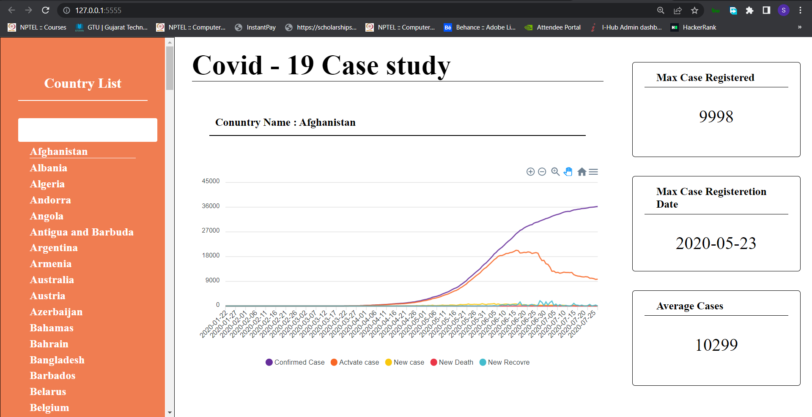

**// Insight of country Angola**

